September 21, 2025, Midland, Texas
MENG 4205.002

Lab 3: Fluid Friction Apparatus

Marcos Esparza, Ngai Thang, Chase Rheinlander, Stanley Galindo
University of Texas Permian Basin
Midland, Texas

Abstract
This experiment investigated fluid flow behavior and head losses in a variety of pipes and fittings using the TecQuipment H408 Fluid Friction Apparatus. Measurements of pressure drop, flow rate, and velocity were used to evaluate energy losses in smooth and rough pipes. Fluid pressure measurement devices such as a free standing 3-way Piezometer unit was also studied to quantify head loss. The results confirmed theoretical expectations that frictional and minor losses increase with flow velocity, and that different geometries and valve types introduce distinct loss coefficients. Experimental results deviated from theoretical predictions by error margins of approximately 76%, 284% and 7% respectively, primarily due to turbulence, measurement inaccuracies, and air bubbles in the Piezometer. Despite these discrepancies, the experimental trends aligned with standard fluid mechanics theory, reinforcing momentum-based analysis of internal pipe flows [1][2].
.

Keywords: Fluid friction, Pipe losses, Head loss, Minor losses, Reynolds number, Friction factor, Venturi, Orifice, Pitot tube, Hydraulic bench, Flow measurement, Energy dissipation, Pressure drop, Pipe roughness

Nomenclature
Q Volumetric Flow Rate (m³/s)
h Head loss (m)
u Velocity (m/s)
d Pipe diameter (m)
ν Kinematic Viscosity (m²/s)
l Length of pipe between tappings (m)
f Friction factor (-)
g Acceleration due to Gravity (9.81 m/s²)
k Loss coefficient (-)
Re Reynolds number (-)
A Cross-sectional area (m²)

- INTRODUCTION
The TecQuipment H408 Fluid Friction Apparatus provides a platform to investigate fundamental fluid mechanics and concepts related to energy losses in various pipe systems. Such studies are critical in understanding the principles governing real-world piping systems, where losses directly impact efficiency, design, and energy consumption. The objective of this experiment was to quantify head losses under different flow conditions and compare experimental results with theoretical predictions based on the Darcy-Weisbach equation, Blasius correlation, and empirical loss coefficients from literature [1][2].
These concepts are central to fluid mechanics and are applied extensively in engineering disciplines ranging from civil water supply systems to chemical process pipelines and mechanical cooling loops [1].
The apparatus incorporates a variety of interchangeable pipe sections and fittings, including smooth and roughened pipes, different bend radii, elbows, valves, strainers, sudden expansions, and contractions, it is good to not that not all are used in this experiment but will be for future ones. This modularity allows for controlled experimentation with a wide range of geometries, making it possible to isolate the effect of each component on energy loss. Pressure tappings connected to piezometer tubes and differential gauges provide accurate measurement of head loss, while the hydraulic bench enables precise flow rate determination using volumetric methods [3][4].
Understanding how fluid friction impacts system performance is essential for engineers. In practice, pipe friction and fitting losses lead to increased pumping requirements, higher operational costs, and reduced efficiency in fluid transport systems. By quantifying these losses under controlled conditions, students gain insight into how design decisions such as pipe diameter, material, and layout influence energy consumption. Additionally, the study of flow measurement devices—venturi, orifice, and pitot tube—illustrates the importance of accurate monitoring and control in fluid systems.
The primary goal of this experiment was to investigate and quantify fluid friction losses across different pipe sections and fittings, compare experimental findings with theoretical predictions, and evaluate the performance of common flow measurement techniques. By linking experimental data with theoretical models, the study reinforces the principles of fluid mechanics while also highlighting practical challenges such as turbulence, trapped air, and measurement uncertainty. The results bridge the gap between fluid mechanics theory and practical engineering systems, emphasizing the importance of minimizing energy dissipation through careful design.

- Theory
Energy losses in pipe systems can be divided into two main categories: major losses and minor losses. Major losses occur due to viscous friction along the length of a straight pipe, while minor losses occur in localized regions where the flow is disturbed by fittings, bends, valves, expansions, or contractions. Both types of losses contribute to reduced efficiency in hydraulic systems and are critical considerations in engineering design.
The head loss in a straight pipe is commonly expressed using the Darcy–Weisbach equation:

$h = (4fl/d) * (u² / 2g)$ (1)

where h is head loss, f is the friction factor, L is the pipe length, D is diameter, u is velocity, and g is gravitational acceleration [2][3]. For smooth turbulent flow, the Blasius correlation provides an empirical approximation of the friction factor:

$f = 0.079Re^(-1/4)$ (2)

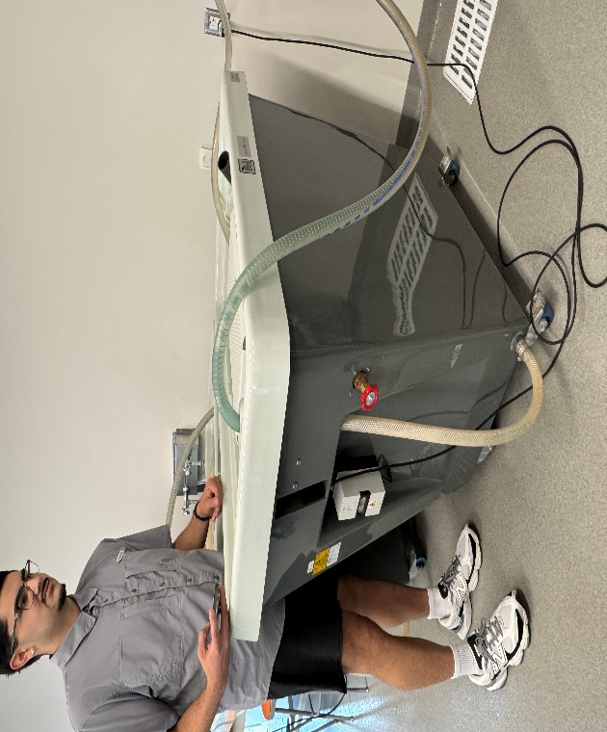
where the Reynolds number, $Re = (uD/ν)$, characterizes the flow regime. For laminar flow, where Re < 2000, the friction factor can be calculated as:
Figure 1 Marcos preparing the tub.

$f = 64/Re$ (3)

Minor losses are modeled using the dimensionless loss coefficient k, which depends on the geometry of the fitting:

$h = k(u² / 2g)$ (4)

Values of k varied between fittings, long-radius bends and fully open ball valves have comparatively low coefficients. These losses add directly to the total system head requirement and therefore affect pump sizing and energy costs [3][4].
The Moody chart provides a graphical representation of the relationship between Reynolds number, pipe roughness, and friction factor. Smooth pipes follow the Blasius line, but roughened pipes deviate upward depending on the ratio of surface roughness height to pipe diameter $(ks/D)$. The H408 apparatus includes both smooth and roughened pipes, allowing direct comparison of measured friction factors against the theoretical chart [2][4].
Flow measurement devices within the apparatus rely on Bernoulli’s principle and continuity. The Venturi meter uses a constricted section to generate a pressure difference that correlates with velocity, while the orifice meter operates on the same principle but introduces greater head loss. The Pitot tube directly measures velocity at a point by comparing stagnation and static pressures. Each method demonstrates tradeoffs between accuracy and energy loss.
In summary, the theoretical framework predicts that head loss varies with the square of velocity, friction factors depend on Reynolds number and surface roughness, and minor loss coefficients depend on geometry. These models provide a baseline for evaluating the experimental data collected from the H408 Fluid Friction Apparatus.

- METHODS
The performance of the H408 Fluid Friction Apparatus was investigated through a structured procedure consisting of preparation, setup, data collection, and repetition across multiple configurations. The apparatus was mounted on a TecQuipment hydraulic bench, which provided the water supply and enabled flow rate measurement by volumetric collection. Pressure drops across different pipe sections were recorded using piezometer tubes and differential pressure gauges [1].

- Preparation of Apparatus
Before testing, the hydraulic bench water supply was inspected to ensure a clean, constant flow. All flexible hose connections were tightened, and the piezometer unit was checked for trapped air. Each experimental section, smooth pipe, roughened pipe, bend, valve, or flow meter, was identified, and the associated tapping’s related to transparent tubing. The hand pump supplied with the apparatus was used to equalize piezometer levels prior to data collection.

- Bleeding and Calibration
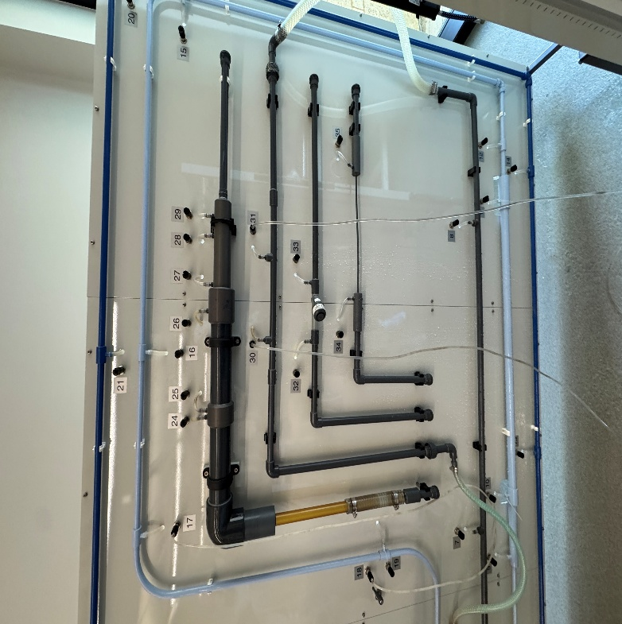
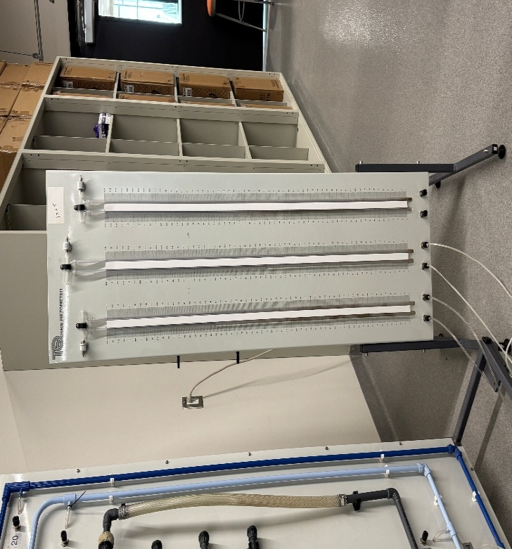
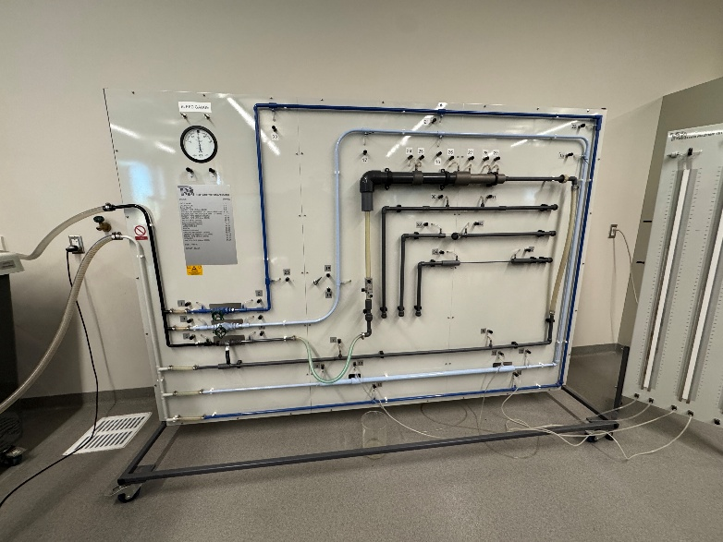
Air was bled from all pipes, piezometers, and differential gauges to prevent inaccurate reading. The pressure gauge bleed valves were opened during high flow to flush out air, and the manometer levels were adjusted to mid-scale using the hand pump. Flow meters (orifice and venturi) were inspected to ensure no blockages.
Figure 4 Rough section outlined in red.
Figure 3 Board with fluid filled meters to measure flow and pressure.
Figure 2 Panel showing all the rough and smooth piping, with bends and valves, smooth piping show.

- Data Collection Procedure
For each experimental configuration, the following steps were performed:

Establish flow: The water supply was turned on and adjusted to the maximum flow rate. The relevant circuit valve was opened while others were closed to isolate the test section.

Record baseline: With flow stabilized, initial manometer or gauge readings were recorded. Volumetric flow rate was determined by timing the collection of a known volume in the hydraulic bench reservoir:

$Q = V / t$ (5)

where V is the collected volume and t is the measured time.

Calculate velocity: The average flow velocity in the pipe was then determined by:

$u = Q / A$ (6)

where $A = (πd² / 4)$ is the cross-sectional area of the pipe.

Measure pressure differences: Head loss values were taken directly from piezometer readings (difference in water column heights) or from the differential gauge. These differences were converted to meters of water head using:

$h = Δp / (ρg)$ (7)

where Δp is the measured pressure difference.

Although not used in this experiment, the loss coefficients: for fittings such as bends, valves, and sudden contractions/expansions, the loss coefficient was computed as:

$k = h / (u² / 2g)$ (8)

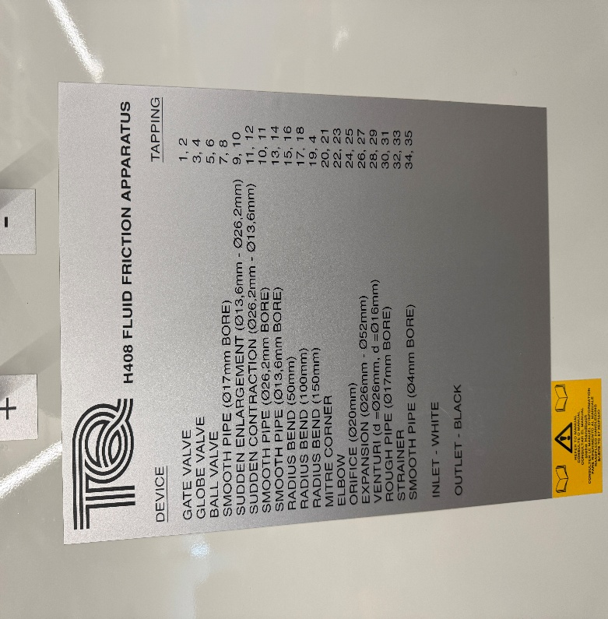
Repeat for multiple flow rates: The procedure was repeated across 5–6 flow conditions per test, ensuring a wide spread of Reynolds numbers for analysis.
Figure 5 Fluid Friction Apparatus device list with Tapping number and bore size.

Repeat for all sections: Identical steps were conducted for smooth and rough pipes, bends of varying radii, sudden expansions and contractions, valves (gate, globe, ball), and the strainer with different filters. Flow meters were assessed separately with simultaneous orifice, venturi, and pitot readings.

3.4Shut Down
At the end of testing, the control valves were closed gradually to prevent water hammer. The piezometer tubes were allowed to drain back, and all hoses were disconnected. The apparatus was wiped down and left to dry to prevent corrosion.

- EXPERIMENTS
The experiments conducted with the H408 Fluid Friction Apparatus were divided into categories based on the geometry and type of component under investigation. Each test followed a common sequence: establishing a steady flow, recording piezometer or differential gauge readings, collecting volumetric flow data, and adjusting the circuit valve to vary the flow rate in controlled steps. Data were later reduced to head losses, friction factors, and loss coefficients.
To evaluate major losses, pressure drops across smooth and roughened pipes of different diameters were measured. Piezometer tubes connected at upstream and downstream tapping points provided the difference in water head. Flow rate was determined volumetrically, and corresponding velocities and Reynolds numbers were calculated. For smooth pipes, results were compared against the Blasius correlation, while the roughened pipe data were compared with the Moody chart to assess the effect of surface roughness.
Head losses in three valve types (gate, globe, and ball) were measured both under fully open and partially open conditions. Pressure drops were recorded with piezometers at low head losses and with the differential pressure gauge at higher losses. For the strainer, both coarse and fine filters were tested to evaluate the impact of filter mesh size on the k factor. Additional runs were performed at varying valve openings to construct curves of k versus percentage opening, allowing direct comparison between valve designs.
The final set of experiments focused on the Venturi meter, Orifice plate, and Pitot tube. For the Venturi and Orifice meters, piezometer tubes measured pressure differences that were used to calculate discharge using Bernoulli’s equation and an assumed discharge coefficient. The Pitot tube was traversed radially across the pipe diameter using the micrometer screw. At each position, the stagnation and static pressure difference was used to calculate local velocity. These results were integrated using Simpson’s Rule to approximate the volumetric flow rate and compare with values obtained from the hydraulic bench.
For all tests, data were collected at approximately five different flow rates ranging from maximum flow down to low flow conditions. Each set of results was plotted to generate performance curves, such as head loss versus velocity squared, friction factor versus Reynolds number, or loss coefficient versus flow rate. Comparisons were made between experimental results and theoretical predictions to assess accuracy and identify discrepancies caused by turbulence, measurement error, and apparatus limitations.

- RESULTS AND DISCUSSION

5.1 Results
The data collected from the H408 Fluid Friction Apparatus consisted of volumetric flow measurements, piezometer readings, and differential gauge values. From these raw measurements, flow rates, velocities, Reynolds numbers, head losses, and loss coefficients were determined. Results were grouped according to test category, including smooth and roughened straight pipes, bends and elbows, sudden expansions and contractions, valves and strainers, and flow measurement devices such as the Venturi, orifice, and pitot tube.
For each configuration, graphs were prepared to illustrate the performance relationships. Head loss plotted against velocity squared produced linear trends, confirming theoretical expectations. Friction factor values were compared against Reynolds number using the Moody chart [2], where smooth pipe data followed the Blasius correlation while roughened pipe results shifted upward due to increased relative roughness. The effect of geometry was also clear in fittings, where bend losses increased with smaller bend radii, expansions produced partial pressure recovery, and contractions generated higher energy dissipation due to vena contracta effects [4]. Valve tests revealed higher head losses in globe valves compared with gate or ball valves, and strainers with finer mesh introduced greater resistance to flow. Flow meter experiments showed the venturi provided the most accurate discharge predictions with minimal energy loss, while the orifice meter exhibited greater losses and the pitot tube confirmed the presence of a parabolic velocity distribution across the pipe diameter [3][4].
Tables summarizing calculated results and figures of the performance curves are included to highlight these relationships and allow comparison to theoretical predictions.
Head Loss in a 13.6mm Straight Smooth Pipe
Time for 15 Liters (s) | Difference (∆h) (m) | Flow Velocity (m.s-1) | Re
83 | 0.25 | 1.24 | 16848.17
86 | 0.24 | 1.20 | 16260.44
89 | 0.22 | 1.16 | 15712.34
103 | 0.18 | 1.00 | 13576.68
143 | 0.10 | 0.72 | 9779.01
Table 1 Constants: Internal Diameter (d) = 0.0136m, Area (A) = 0.0001453$m^{2}$, Length (l) = 0.912m
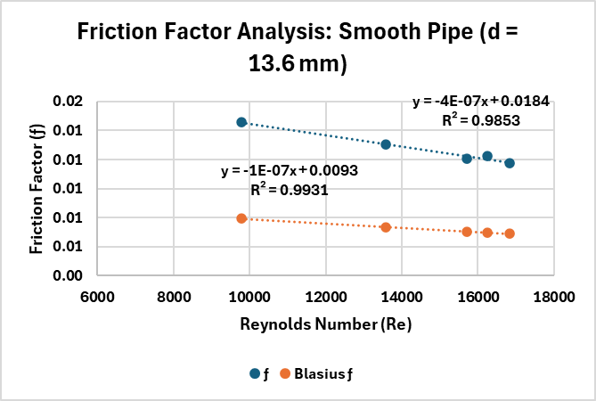
Figure 6 Constants: Internal Diameter (d) = 0.0262m, Area (A) = 0.0005391$m^{2}$, Length (l) = 0.912m
Head Loss in a 26.2mm Straight Smooth Pipe
Time for 5 Liters (s) | Difference (∆h) (m) | Flow Velocity (m.s-1) | Re
41 | 0.01 | 0.23 | 5903.16
42 | 0.01 | 0.22 | 5762.61
43 | 0.01 | 0.22 | 5628.59
46 | 0.01 | 0.20 | 5261.51
58 | 0.01 | 0.16 | 4172.92
Table 2 Data table for 26.2mm Smooth Straight Pipe

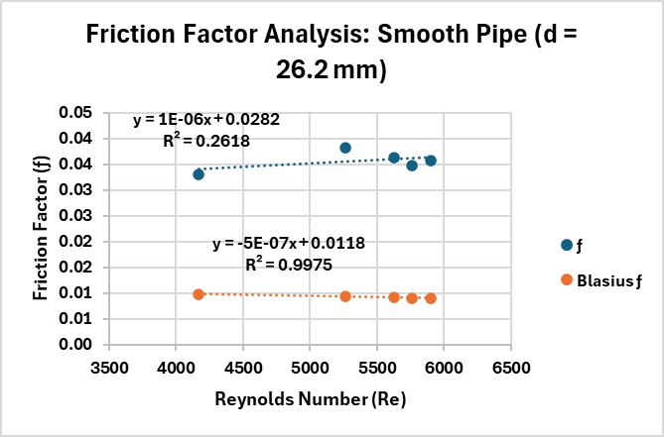
Figure 7 Constants: Internal Diameter (d) = 0.014m, Area (A) = 0.0001539$m^{2}$, Length (l) = 0.2m
Head Loss in a 14mm Straight Rough Pipe
Time for 5 Liters (s) | Difference (∆h) (m) | Flow Velocity (m.s-1) | Re
53 | 0.09 | 0.61 | 8547.71
62 | 0.07 | 0.52 | 7306.91
86 | 0.03 | 0.38 | 5267.78
103 | 0.02 | 0.32 | 4398.34
124 | 0.01 | 0.26 | 3653.46
Table 3 Data table for 14mm Straight Rough Pipe
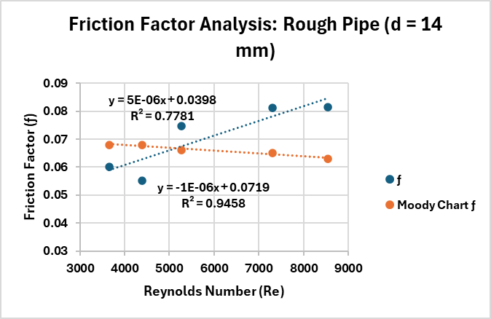
Figure 8 Scatter Chart with trendline showing the Friction Factor of the 14mm Rough Pipe

5.2 Sample Calculations
An example calculation is shown for the smooth pipe test:
Volumetric Flow Rate
$$Q = V / t$$
Where V = 5.0 L and t = 12.5 s:
$Q = 0.005 / 12.5 = 0.0004 m³/s$
Velocity
$$u = Q / A ; A = (πd² / 4)$$Where Q = 1.81E-04 and A = 0.0001453m²

Thus u = 1.81E-04/0.0001453m² = 1.24 m/s
Reynolds Number
$$Re = ud / ν$$
Taking u = 1.24 m/s, d = 0.0136m and v = 1.004E-06

Then Re =1.24(0.0136) / 1.004E-06 = 16848.17
Head Loss from Piezometer Readings
$$h = Δp / (ρg) = Δh$$
From our first trial, Δp = (628 – 379) mm and knowing the established density of water at room temperature, and gravity’s acceleration yields Δh = 0.25 m (converting to meters).
Friction Factor
$$f = (hgd) / (2l(u² ))$$

Using the calculated values for head loss, and flow velocity and taking d = 0.0136m from our smooth pipe (Tap Num 13,14) data along with the length ($l$) = 0.912m we calculate the friction factor as follows:
$$f = (9.81 ×0.25×0.0136) / (2×0.912(1,24² ))$$

$$f = 0.01$$

5.3 Ideal vs. Actual Comparison
Theoretical predictions for straight pipes followed the Blasius correlation for smooth turbulent flow and Moody chart relationships for roughened pipes. The 13.6mm SSP and the 14mm SRP followed it fairly accurately, however, the 26.2mm SSP was an outlier. These differences were attributed to trapped air in piezometers, turbulence at fittings, and slight timing errors in volumetric collection.
For fittings, loss coefficients (k) matched tabulated values from the manual but were consistently higher at low flow rates due to instability in the flow regime. Valve losses were strongly dependent on valve type, with the globe valve showing the highest k, consistent with its tortuous flow path.
Flow meters also showed expected trends: Venturi meters provided the closest agreement with theoretical discharge, orifice meters exhibited higher energy losses, and Pitot profiles confirmed non-uniform velocity distribution across the pipe.
5.4 Discussion
The experiments demonstrated that hydraulic losses depend strongly on velocity, geometry, and flow regime. Straight pipe results validated the fundamental predictions of the Darcy–Weisbach equation and highlighted the effect of relative roughness in practical systems. Fitting tests reinforced the importance of gradual redirection of flow, as larger bend radii produced smaller energy losses compared to sharp elbows and mitre corners. Expansion and contraction tests showed that sudden changes in diameter create turbulence and energy dissipation, with contractions producing the greatest head losses due to vena contracta effects [4].
Although the pipe was labeled as “smooth,” the experimental results showed it actually had measurable roughness (table 1, Figure 6). The friction factor initially followed Blasius predictions, but the calculated relative roughness (ks/d ≈ 0.02–0.05) from the Moody chart placed it in the transition zone rather than being truly smooth. The percentage error compared to the Blasius friction factor was about 76%. As expected, the friction factor decreased with increasing Reynolds number. This shows that in practice, “smooth” pipes still tend to have surface roughness.
When looking at the 26.2 mm pipe labeled as “smooth,” the results showed a similar story to the 13.2 pipe behavior. The experimental friction factors deviated significantly from Blasius predictions, with a percentage error of about 284% (table 2, figure 7). The calculated relative roughness (>0.05 from the Moody chart) placed it in the rough pipe category. Unlike smooth or transitional pipes, the friction factor increased with Reynolds number, which is characteristic of fully rough flow. This suggests the pipe may have had surface issues such as corrosion, deposits, or a poor finish.
Lastly, the 14 mm pipe behaved as expected for a rough pipe (table 3, figure 8). The Blasius equation completely failed, while the experimental friction factors closely matched the Moody chart, with only about 7% error. Using the known relative roughness (ks/d = 0.036) confirmed the Moody chart’s accuracy.
This shows a key principle in fluid mechanics: the Blasius equation only works for smooth pipes. Once roughness is significant, friction depends on relative roughness rather than Reynolds number
Valve and strainer tests emphasized the role of component design, with globe valves demonstrating significantly greater resistance than gate or ball valves, and strainers showing that finer mesh sizes restrict flow more severely. Flow meter tests provided insight into the tradeoffs between accuracy and energy loss, confirming the venturi as the most efficient, the orifice as less efficient but simpler, and the pitot as a useful tool for velocity profile measurements despite its limitations in estimating bulk flow rate.
Overall, the results confirmed the theoretical framework of internal fluid flow while also demonstrating the practical challenges of measurement accuracy, turbulence, and equipment limitations.

- CONCLUSION
The Fluid Friction Apparatus experiment provided straightforward evidence of the way energy is dissipated in internal pipe flows through both major and minor losses. Measurements taken across smooth and roughened pipes confirmed the dependency of the friction factor on Reynolds number and relative roughness, with smooth pipe results aligning with the Blasius correlation and roughened pipe data showing the expected upward shift on the Moody chart.
Fitting experiments demonstrated the strong influence of geometry on head losses. Bends with larger radii produced smaller losses, while sharp elbows and mitre corners caused more pronounced energy dissipation. Sudden expansions showed partial pressure recovery but significant turbulence, while contractions produced the highest losses due to vena contracta effects. Valve testing revealed the substantial resistance introduced by globe valves compared to gate and ball valves, and strainer experiments highlighted the effect of obstruction size on pressure drop.
Flow measurement experiments reinforced the principles of Bernoulli’s equation and continuity. The venturi meter proved to be the most reliable method with the least energy loss, the orifice meter offered reasonable performance with greater losses, and the pitot tube successfully illustrated the velocity distribution across the pipe diameter.
Although deviations of 76%, 284%, and 7% were observed between the experimental and theoretical values, these differences can be attributed to unavoidable sources of error. Contributing factors included turbulence, the “smooth” pipe not being perfectly smooth, the rough pipe piezometer having to be set at a -7 starting value due to unleveled meters, as well as issues such as air in the piezometers and timing inaccuracies. Despite these limitations, the overall results aligned well with theoretical predictions and effectively demonstrated the governing principles of internal flow from the general trends and predictions in our data as well as empirical observation.
The experiment not only validated fluid mechanics theory but also emphasized the importance of considering both major and minor losses in the design of practical piping systems. By showing how geometry, flow regime, and component choice affect system performance, the study reinforced fundamental concepts essential to mechanical, civil, and chemical engineering applications [1][2][3][4].

- REFERENCES

[1] TecQuipment Ltd. Fluid Friction Apparatus H408 User Guide, Nottingham, UK, 2012.

[2] White, Frank M. Fluid Mechanics, 8th ed., McGraw-Hill, 2016.

[3] Munson, Bruce R., et al. Fundamentals of Fluid Mechanics, 7th ed., Wiley, 2013.

[4] Çengel, Yunus A., and Cimbala, John M. Fluid Mechanics: Fundamentals and Applications, 4th ed., McGraw-Hill, New York, 2018

APPENDIX

Raw Data: Experiment One
Pipe type: 13.6 Smooth Straight Pipe
Internal Diameter (d) = 0.0136 m
Area (A) = 0.0001453 $m^{2}$
Length (l) = 0.912 m
Percentage Error: 76%
Time for 15 Liters (s) | Flow Rate (Q) (m³.s⁻¹) | Upstream Tapping (mm) | Downstream Tapping (mm) | Difference (∆h) (m) | Flow Velocity (m.s⁻¹) | Re | ƒ | Blasius ƒ | k_{s}/d
83.00 | 1.81E-04 | 628.00 | 379.00 | 0.25 | 1.24 | 16848.17 | 0.01 | 0.01 | 0.05
86.00 | 1.74E-04 | 607.00 | 366.00 | 0.24 | 1.20 | 16260.44 | 0.01 | 0.01 | 0.02
89.00 | 1.69E-04 | 582.00 | 360.00 | 0.22 | 1.16 | 15712.34 | 0.01 | 0.01 | 0.02
103.00 | 1.46E-04 | 504.00 | 325.00 | 0.18 | 1.00 | 13576.68 | 0.01 | 0.01 | 0.02
143.00 | 1.05E-04 | 368.00 | 264.00 | 0.10 | 0.72 | 9779.01 | 0.01 | 0.01 | 0.03

Raw Data: Experiment Two
Pipe Type: 26.2 mm Smooth Straight Pipe
Internal Diameter (d) = 0.0262 m
Area (A) = 0.0005391 $m^{2}$
Length (l) = 0.912 m
Percentage Error: 284%
Time for 5 Liters (s) | Flow Rate (Q) (m3.s-1) | Upstream Tapping (mm) | Downstream Tapping (mm) | Difference (∆h) (m) | Flow Velocity (m.s-1) | Re | ƒ | Blasius ƒ | K_{s}/d
41.00 | 1.22E-04 | 802.00 | 789.00 | 0.01 | 0.23 | 5903.16 | 0.04 | 0.01 | ≥0.05
42.00 | 1.19E-04 | 795.00 | 783.00 | 0.01 | 0.22 | 5762.61 | 0.03 | 0.01 | ≥0.05
43.00 | 1.16E-04 | 783.00 | 771.00 | 0.01 | 0.22 | 5628.59 | 0.04 | 0.01 | ≥0.05
46.00 | 1.09E-04 | 765.00 | 754.00 | 0.01 | 0.20 | 5261.51 | 0.04 | 0.01 | ≥0.05
58.00 | 8.62E-05 | 695.00 | 689.00 | 0.01 | 0.16 | 4172.92 | 0.03 | 0.01 | ≥0.05

Raw Data: Experiment Three
Pipe Type: 14mm Rough Straight Pipe
Internal Diameter (d) = 0.014 m
Area (A) = 0.0001539 $m^{2}$
Length (l) = 0.2 m
Percentage Error: 7%

Time for 5 Liters (s) | Flow Rate (Q) (m3.s-1) | Upstream Tapping (mm) | Downstream Tapping (mm) | Difference (∆h) (m) | Flow Velocity (m.s-1) | Re | ƒ | Blasius ƒ | Moody Chart ƒ
53.00 | 9.43E-05 | 545.00 | 449.00 | 0.09 | 0.61 | 8547.71 | 0.08 | 0.01 | 0.06
62.00 | 8.06E-05 | 485.00 | 413.00 | 0.07 | 0.52 | 7306.91 | 0.08 | 0.01 | 0.07
86.00 | 5.81E-05 | 351.00 | 313.00 | 0.03 | 0.38 | 5267.78 | 0.07 | 0.01 | 0.07
103.00 | 4.85E-05 | 292.00 | 269.00 | 0.02 | 0.32 | 4398.34 | 0.06 | 0.01 | 0.07
124.00 | 4.03E-05 | 263.00 | 244.00 | 0.01 | 0.26 | 3653.46 | 0.06 | 0.01 | 0.07

Moody Chart with Found Values for Rough Pipe
